Data Flow Diagram
Date | 29 September 2026
Team ID | [Enter Team ID]
Project Name | Streamlining IT Procurement: Automating Standard Laptop Orders With Flow Designer
Maximum Marks | 2 Marks
Data Flow Diagram
Create a Data Flow Diagram (DFD) to show how data moves through your system - between external entities, processes, and data stores. Use the symbol legend below as a guide.
DFD Symbol Legend
Symbol | Name | Description
Oval / Rounded shape | External Entity | A person, organization, or system outside the project that sends or receives data (e.g., Customer, Payment Gateway).
Rectangle with numbered header | Process | An activity that transforms incoming data into outgoing data (e.g., Validate Request, Process Order).
Rectangle (solid fill, no number) | Data Store | A place where data is held for later use (e.g., Customer Database, Inventory).
Labeled arrow | Data Flow | The movement of data between entities, processes, and data stores, labeled with what data is being passed.
Data Flow Diagram: Automating Standard Laptop Orders
The diagram below shows how data moves between the employee, the Hardware team, the three processes and the two data stores of the laptop ordering system.
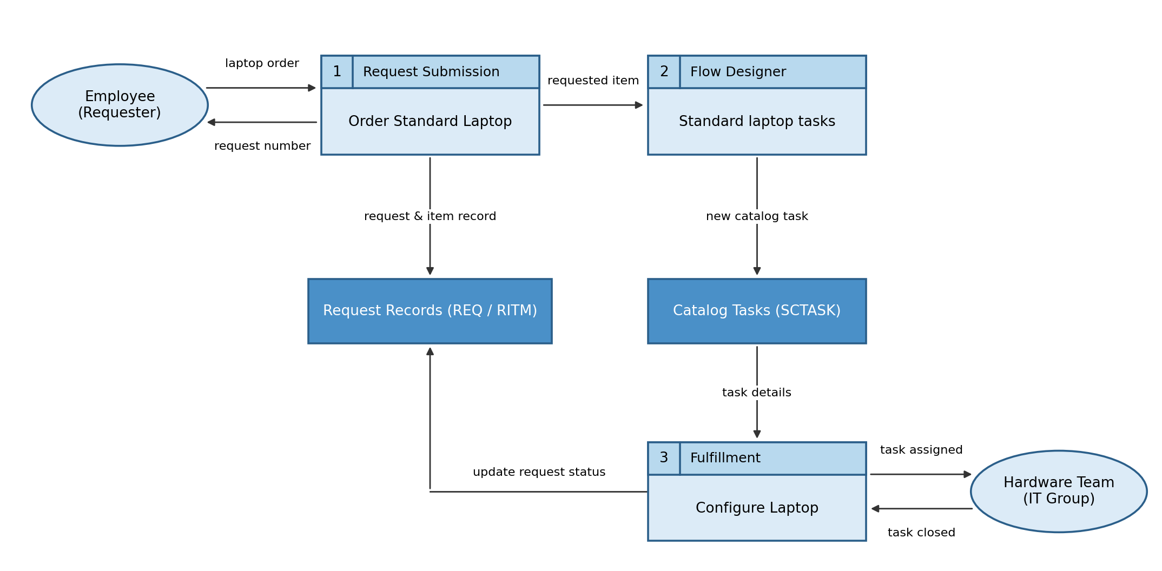
Process Description
No. | Process | Description
1 | Request Submission | The employee opens the Service Catalog, selects Standard Laptop and clicks Order Now. A request (REQ) and requested item (RITM) are created and the request number is shown.
2 | Flow Designer Flow | The flow "Standard laptop tasks" is triggered by the Service Catalog and runs the Create Catalog Task action for the requested item.
3 | Task Fulfillment | The catalog task (SCTASK, assigned to the Hardware group) is worked by the Hardware team. When the laptop is configured the task is closed and the request status is updated.

